 | from the headteacher  Dear St Peter’s Families,  This term was a very positive and productive one for our school, with pupils and staff working hard and making the most of a wide range of learning opportunities. There was a strong focus on both academic progress and personal development, and it was wonderful to see the enthusiasm, effort, and commitment shown across the school community.  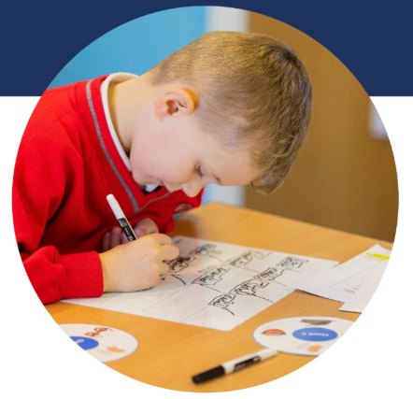  During this term, pupils across the school took part in a range of engaging learning opportunities designed to enrich the curriculum. Children participated in fire safety workshops, where they learned how to stay safe and what to do in an emergency. Pupils also enjoyed a historical workshop focused on kings and queens, which helped bring history to life through interactive activities.  Selected pupils were given the opportunity to take part in greater depth maths sessions, providing additional challenge and developing problem-solving skills. Year 5 pupils also attended swimming lessons throughout the month, where they worked on improving their technique, water confidence, and essential life skills  As a school, we were also involved in professional generosity, giving back to other teachers and schools. This term, our focus was on active spelling showcase events and on supporting the development of English teaching and learning across the county. Our spring visit from the local authority was a huge success and celebrated the efforts made in transcription across the school.  On another note, Miss Smith had a baby boy in January. She has called him Ollie and they are both doing well. I’m sure Miss Smith will bring Ollie to St Peter’s in the near future!  We look forward to seeing everyone on Monday 23rd February 2026 for another great term!  With warmest wishes,  Emily Mayer  Headteacher  PARKING    We understand that parking at drop-off and pick-up times can be challenging, particularly during busy periods. However, we would like to remind parents and carers of the importance of parking safely and considerately when dropping off and collecting children. Please avoid parking on double yellow lines, blocking driveways, or stopping in areas that may cause obstruction or risk to pedestrians. By allowing a little extra time and parking responsibly, we can work together to keep everyone in our school community safe, especially our pupils and local residents.  friends of the school  We are delighted to share that our recent Friendship Disco was a fantastic success! The hall was filled with music, laughter and plenty of energetic dance moves from both the children and the adults. It was wonderful to see our school community come together for such a joyful evening.  Thanks to your incredible support, we raised approximately £450. This money will go straight back into our FoftS fund to provide amazing opportunities that simply wouldn’t be possible through school funding alone. These include experiences such as the Little Learners Sundown Adventure trip, beach trips, workshops, and additional resources that enrich our children’s learning and create lasting memories. None of this would be achievable without the fantastic support from our parents and carers when we hold these events - so thank you!  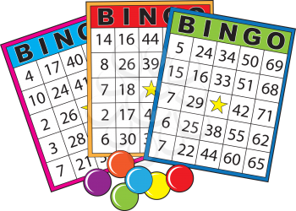  We’re also excited to give you a heads up about our upcoming Bingo Event!  Date: Wednesday 1st April 2026  Time: 3.15pm - 5.00pm  Tickets: £5 per ticket (includes 4 games of bingo and a hotdog)  There are some amazing prizes up for grabs! Please note this event is for children only due to space restrictions. However, Reception children may attend with one adult accompanying them to help them play the game, this comes at no additional cost, but adults will not be served food.  Tickets will be limited and sold on a first come, first served basis, so keep your eyes peeled for when they go on sale to avoid missing out!  If you would like to become part of our Friends of the School volunteer team, we would love to hear from you. Please speak to the school office for more information. It’s fun, rewarding, and a great opportunity for us as parents and carers to give back to the school while helping to create exciting experiences for all of our children.  Thank you again for your continued support.  Warm wishes,  The Friends of the School Committee (PTA)  Mrs PINNEY’s Book review  diary dates  Friday 13th February - Children finish for half term  Monday 23rd February - Children return to school  Tuesday 24th February - Year 6 at Forest School  Wednesday 25th February - Year 5 Swimming starts  W/c Monday 2nd March - Library Visits  Tuesday 3rd March - Year 5 at Forest School  Thursday 5th March - World Book Day  Friday 6th March - Class Photograph Day  Tuesday 10th March - Year 4 at Forest School  Friday 13th March - Year 5 Visit to Lincoln Cathedral  Tuesday 17th March - Year 3 at Forest School  Tuesday 24th March & Wednesday 25th March - Parents’ Evenings  Friday 27th March - School clubs finish  Monday 30th March - Spring Caring Event  Wednesday 1st April - Easter Church Service  Wednesday 1st April - Friends of the School Bingo Event  Thursday 2nd April - Children finish for Easter break  term dates  Please do take note of the term dates below and remember that every day in school is vital for all children.  2025-2026 Term Dates  Term 1 - Thursday 4th September to Thursday 23rd October 2025  Term 2 - Monday 3rd November to Friday 19th December 2025  Term 3 - Tuesday 6th January to Friday 13th February 2026  Term 4 - Monday 23rd February to Thursday 2nd April 2026  Term 5 - Tuesday 21st April to Friday 22nd May 2026  Term 6 - Monday 1st June to Wednesday 22nd July 2026
  
  Saint peter at Gowts
  February NewSletter 2026
  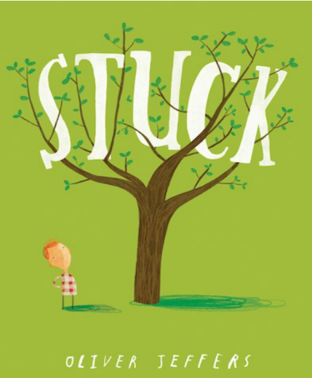
  A book we have been enjoying in Year 1 is ‘Stuck’ by Oliver Jeffers. In the book Floyd gets his kite stuck in a tree and makes lots of silly choices when trying to find a way to get the kite down.
  We enjoyed laughing at the silly things Floyd does and making predictions about what he might do next. One of our favourite things about the story is the ending. When the book ends there is still a problem! We love coming up with our own ideas of how to solve the problem and making suggestions about what could happen next.

