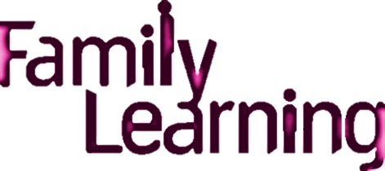



**Let's Get Crafty!**

This is a free Family Learning workshop

for mums, dads, grandparents and carers!

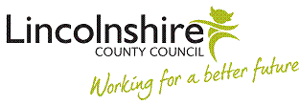

Would you like to know how to create simple art and craft activities?

Would you like to get creative with your child?

Would you like to meet new people?

Then this workshop is for you!

**Course Details**

**Date: 21stth May**

**Day: Friday**

**Time: 1pm -2.45pm**

**Venue: St Peter at Gowts School**

**Contact:** **Samantha Robinson or Kinga Wilson**

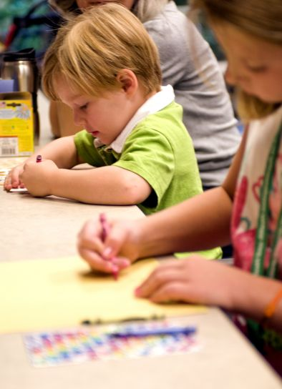

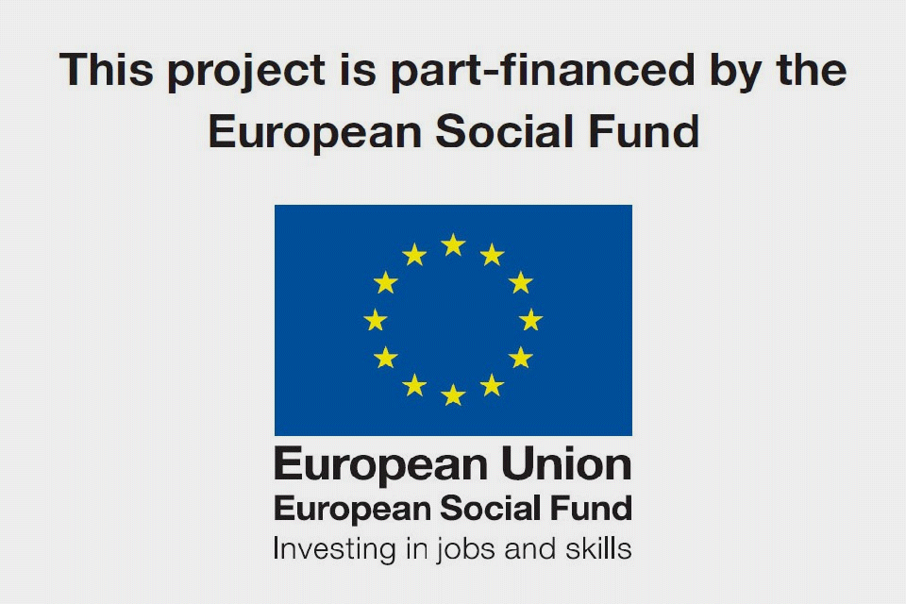

You may be eligible to apply for childcare or travel costs.

Please contact Samantha Robinson for more information.