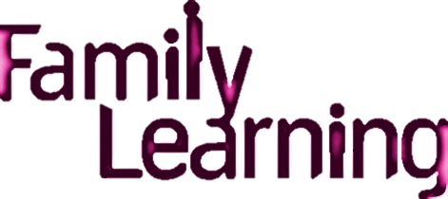



**Fun and Games for Early Years**

This is a free Family Learning course

available to all mums, dads, grandparents and carers!



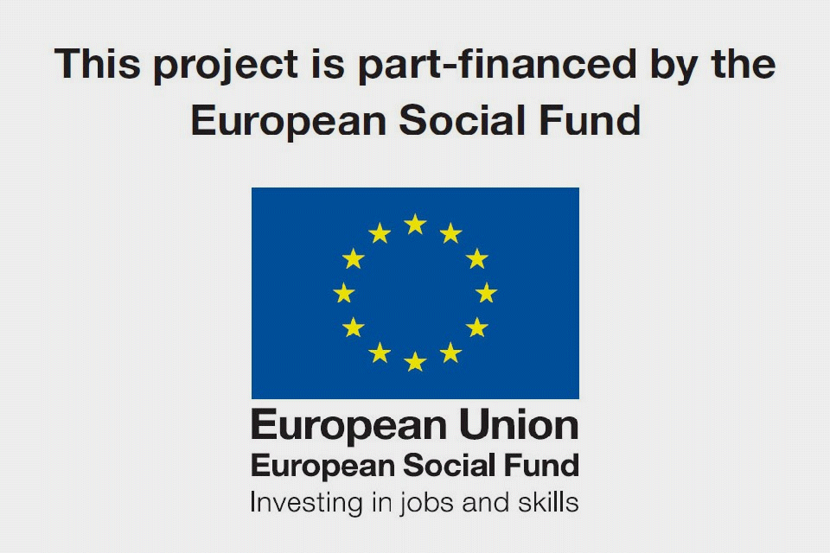

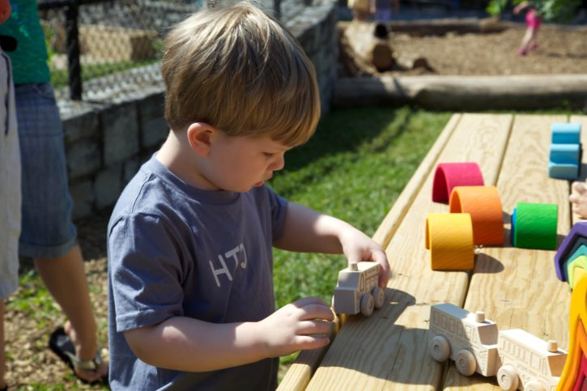

Do you like playing games, singing songs and telling stories?

Why is this so important?

How do we learn?

Want to meet new people and gain new skills?

This course is for you!

**Course Details**

**Date: 14th May**

**Day: Thursday**

**Time: 1pm-2.45pm**

**Venue: St Peter at Gowts CofE Primary School**

Contact: Samantha Robinson or Kinga Wilson

You may be eligible to apply for childcare or travel costs.

Please contact Samantha Robinson Nice-likefor more information.