



**Family Fun Outdoors**

This is a free Family Learning course

available to all mums, dads, grandparents and carers!



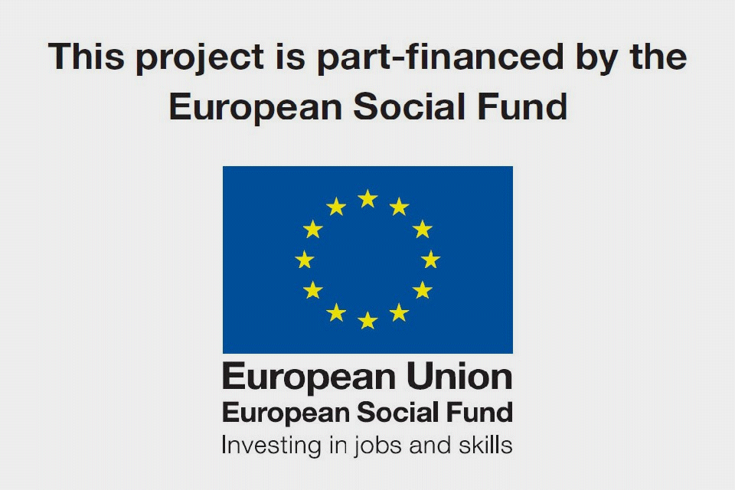

Do you like being outdoors?

Do you want to learn about what games you can play outside?

Why is playing outside important?

Would you like to meet new people and gain new skills?

This course is for you!

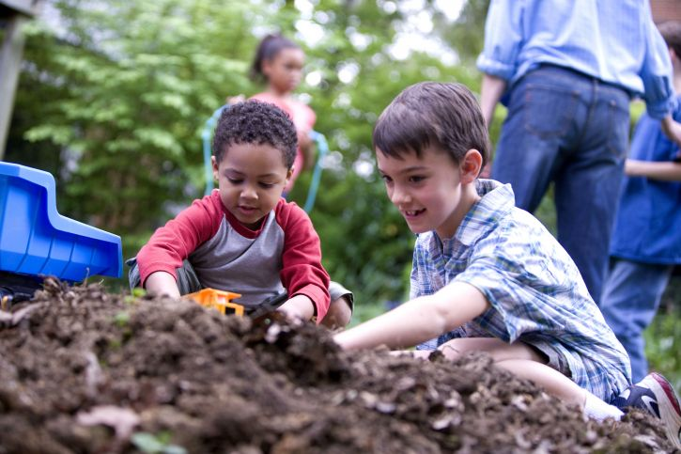

**Course Details**

**Date: 10th June-15th July 2021**

**Day: Thursdays**

**Time: 1pm-3pm**

**Venue: St Peter at Gowts CofE Primary school**

Contact: Samantha Robinson or Kinga Wilson

You may be eligible to apply for childcare or travel costs.

Please contact Samantha Robinson for more information.