# School Feedback

### Feedback from schools who have participated in Family Learning courses:

*"As a result of the parents attending the ESOL course, parents have become more involved in the school community, joined in social events within the school, and we are looking to build on this in any way possible. The sessions have broken down invisible barriers between parents and school, and this has led to a more open and communicative relationship."*

**ESOL, John Fielding Special School**

*"It has become part of the DNA of the school. We deliver sustainability courses in the child's reception year and therefore, due to effective recruitment, are able to recruit and engage parents more readily into the Family English programme when their child enters Year 1. The Family English course enables us to send key messages regarding specific skills e.g. phonics which facilitates effective learning opportunities at home."*

**Family English, The Magdalen C of E / Methodist School.**

*"All learners made good progress. I saw a difference in two y2 pupils who thoroughly enjoyed the session and home learning was now an enjoyable experience.*

*Carers were really interested in the sessions which were fun, practical and allowed them to really get to grips with the Maths that is taught in Y2."*

**Keeping up with the Children with Maths - Heighington Millfield Primary Academy**

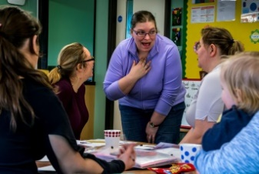

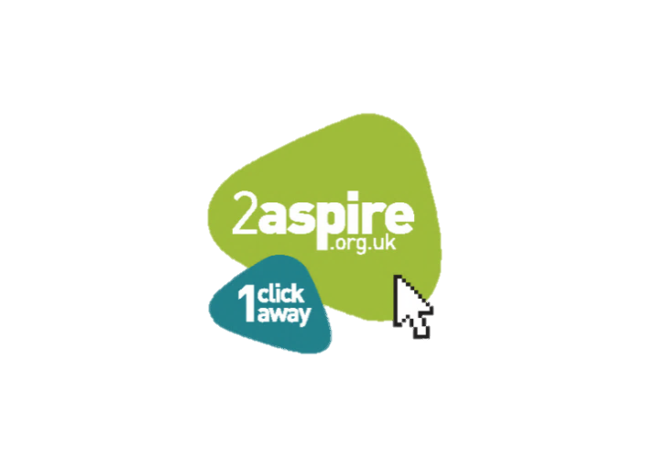



*'Leaders and managers have worked tirelessly to promote a positive culture across the council that celebrates learning, achievement and social inclusion'*

**OFSTED 2019**

# Contact Details

Family Learning is part of the Adult Skills and Family Learning Service and is delivered out of the Learning Office in Sleaford. Please find below our contact details:

**Adult Skills and Family Learning Team**

Enterprise, Growth and Learning

Lincolnshire County Council

Sleaford Area Office

Office 2 Sleaford

Lincolnshire

NG34 7EB

[Email: [BS_LearningLH@lincolnshire.gov.uk](https://csprod.lcc.cloud.opentext.eu/contentserverdav/nodes/51897989/BS_LearningLH%40lincolnshire.gov.uk)](https://csprod.lcc.cloud.opentext.eu/contentserverdav/nodes/51897989/%20BS_learninglh%40lincolnshire.gov.uk)

Tel: 01522 782011

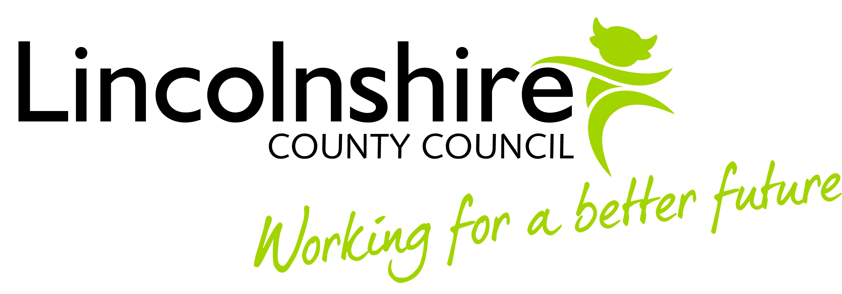

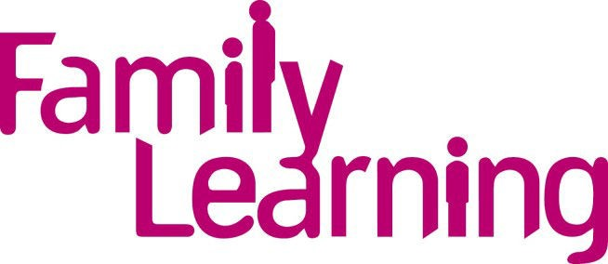

# in Lincolnshire 2019/20

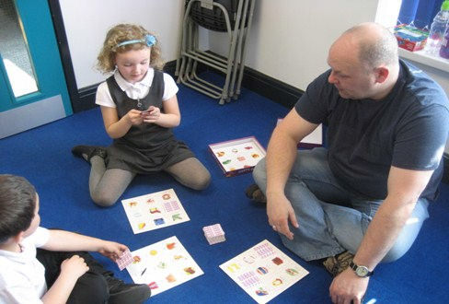

*(Fun with Numbers)*

# What is Family Learning?

Family Learning is a national programme established to help parents and carers support their child’s learning whilst improving their own English and/or Maths skills.

We can offer a wide range of quality courses, which are delivered by a team of trained professionals.

Family Learning gives parents/carers the chance to learn new skills and support their child’s learning in a fun and friendly way.

# Why Family Learning?

Family Learning successfully engages with hard to reach learners because the emphasis is placed on supporting their children rather than explicitly addressing a learning need, developing constructive parent-school relationships.

Parents gain positive benefits from the courses. They enjoy the time they can spend with their children away from the pressures of family life and many gain an understanding of how modern schools work, and how literacy and numeracy are taught.

Having participated in the courses, many of the parents have gone on to work in schools as supervisors, teaching assistants, reading volunteers and parent helpers. Some parents have also gone on to become school governors.

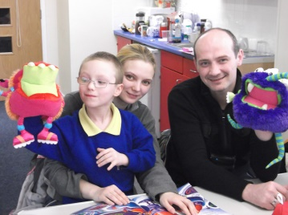

# Benefits to Participating Schools

## Meets OFSTED requirements through engaging parents in supporting pupils' achievement, behaviour and their spiritual, moral, social and cultural development.

* **Proven to help improve children’s attainment.**
* **Improves partnerships between parents and their child's school.**
* ***'Learners develop excellent employability and personal and social skills'* OFSTED 2019**
* **Fully funded by the Education & Skills Funding Agency through Lincolnshire County Council.**

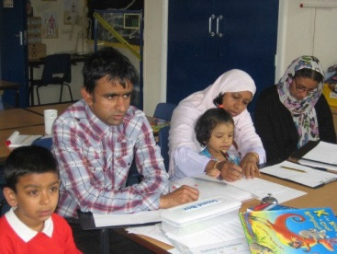

*(Family ESOL)*

**Family Learning Courses**

There are a variety of courses provided by Family Learning in Lincolnshire. Courses can be adapted according to school requirements.

A course can be between 6 –15 weeks depending on the subject. A session is between 2 – 3 hours depending on the length of the course.

A taste of the courses available are listed below:

Family English

Family Maths

Family English for Speakers of Other Languages (ESOL)

Keeping Up With The Children ICT

Healthy Living and Family Wellbeing

Story Sacks and Phonics

Learning Through Play

Sustainability – Arts and Crafts

Sustainability – Feed Your Family on a Fiver

Sustainability – Grow Your Own

Sustainability - Family Fun Outdoors

**All courses are fully funded**