Learning Project WEEK 1 - My Family
Age Range: KS1
Weekly Maths Tasks (Aim to do 1 per day) | Weekly Reading Tasks (Aim to do 1 per day)
- Working on Numbots - your child will have an individual login to access this.  - Play on Hit the Button - number bonds, halves, doubles and times tables.  - Practise counting in 2s, 5s and 10s. This game could support this.  - Work on a shopping list for the weekly shop and get children to add up how many items and add up the cost of some items. This game could support work on making amounts of money.  - Practise telling the time. This could be done through this game (scroll down to access the game). Read to the hour and half hour.  - Write the numbers 0-20 in words and digits. | - Reading a variety of books at home. Your child could share a book everyday. This can be reading a book aloud everyday or sharing a book with an adult.  - Listen to a story read, Storytime.  - Watch Newsround and find out what is happening in the world. What did you find out? Is there anything you need help understanding?  - Create a bookmark, perhaps you could choose characters from your favourite stories.  - Complete a book review on one of the books you have read - what did you like about it? Would you recommend it to anyone?
Weekly Phonics/Spellings  Tasks (Aim to do 1 per day) | Weekly Writing Tasks (Aim to do 1 per day)
- Daily phonics - your child to practice their sounds and blend words. Interactive games found on link below.  - Phonics play  - Top Marks  - Spelling  - Spell the days of the week: Keep a diary of things you do in the week.  - Spell common exception words  - Spelling City | - Family: Look at a family in a traditional story - how are they different to your family? Can you write sentences comparing the two families?  - Take a look at a variety of poems with your child. Ask them to pick their favourite poem and write a poem https://www.poetry4kids.com/topic/family/  - Write a letter or postcard - find out about different postcards and why people write them. Can they design the front of the postcard and then plan what to write and who they could write it too.  - Ask your child to create a story about their family. Who will be the main characters ? Where will the setting place
Learning Project - to be done throughout the week: My Family 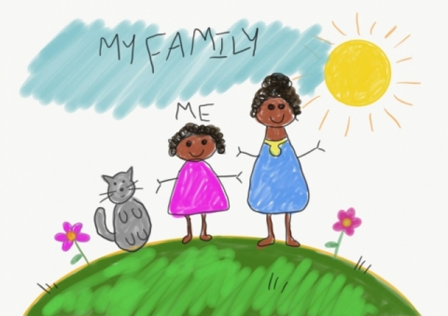
The project this week aims to provide opportunities for your child to gain a better understanding of their own family. Learning may focus on what different makeup of families, what traditions your family has, stories linked to your family etc.

Family:

- This is time to find out about their family and traditions they follow. Ask them to think about: Who they live with? How many adults? How many children? Can they sort their family members into height order? Who is the tallest? Who is the shortest? Is the tallest family member the eldest family member? If they drew around all their family members' hands; could they count in 5s? What if they drew around their feet? Could they count in 2s? Ask think about one family member they would love to interview. They could be a family member that lives with them or a family member that lives somewhere else. Can they write down some questions they would like to ask them? Have they got a pet? Can they draw or paint a picture of their family? Can they talk about their picture to a family member?

Self portrait:

- Ask your child to think about which materials they use to draw? Can they find different materials around the house to help? Ideas

Create a card:

- Ask your child to design a card for someone in their family. It can be a birthday card, thank you card or a card to tell someone how much they love them!

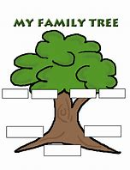
Family tree:

- Look at photographs of your family members and discuss where they would go on a family tree. Have you met everyone? Is there anyone you could interview and find out more about?

Design a personal coat of arms shield for the family:

- Find out what a coat of arm shield means. Ask them to begin to think about their design. What could they draw? What does it mean to them ? Ask them to think about the colours and shapes. Maybe if they have some cardboard around the house they could make a shield to give to a family member.

Create a booklet all about the family:

- Can they name the people in their family and write sentences about them? Who are they? What do they call them? What do they like or dislike? Why are they special to them? Maybe they could get a photograph or draw a family member before they write about them.

News Reporter for half a day:

-Their challenge is to interview family members and find things they like and dislike? Can they write down things they like and dislike? Can they compare these to someone else in their family? In your interview they could create flashcards with words such as: colour, clothes, food, drinks, books, places, music and then ask a family member to pick a flash card and talk about their likes and dislikes.

Data detective Ask your child to look at people in the house. What colour is their hair ? Eye colour? Favourite colour? Favourite food? Ask them to collect this and place in a tally chart.
https://www.twinkl.com.qa/resource/t2-m-250-favourite-colour-tally-and-bar-chart-worksheets

Interview a family member:

- interview a family member that doesn’t live at home with them. Allow your child to ask them about their childhood. Who did they live with? Who is in their family? Have they got any family traditions they follow and why.

Write an invitation to a family event: Ask your child to invite a family member to one of the following: - (talent show, music show, magic tricks, jokest) In their invitation ask them to think about the time, date and place. How will they design the invitation? Who will deliver it?
Share the https://family.gonoodle.com/activities/milkshake movement and mindfulness video with their family. Who was the best? Which part did they enjoy? Could you create a video of your own?

Additional learning resources parents may wish to engage with
Classroom Secrets Learning Packs - These packs are split into different year groups and include activities linked to reading, writing, maths and practical ideas you can do around the home.
Twinkl - to access these resources click on the link and sign up using your own email address and creating your own password. Use the offer code UKTWINKLHELPS.
Headteacherchat - This is a blog that has links to various learning platforms. Lots of these are free to access.

Additional Year 1 phonics support can be found here:
https://home.oxfordowl.co.uk/reading/learn-to-read-phonics/

Additional year 2 work to support SATs can be found here: https://www.theschoolrun.com/key-stage-1-sats-learning-journey

#TheLearningProjects

