Learning Project WEEK 7
Age Range: Little Learners
Daily Ideas for your children
A Little Movement in your Days!  Use these websites to help your children have fun being active!  Try for at least one activity a day. They love these in school!  Just Dance for Kids  https://www.youtube.com/watch?v=41SkJVsm7Os  Cosmic Yoga Activity  https://www.youtube.com/user/CosmicKidsYoga  Go Noodle  https://app.gonoodle.com/ | Speaking and Listening  Enjoy choosing and singing some nursery rhymes with your children. These websites have some good links!  https://www.youtube.com/watch?v=wV3N-wCRL2k  Have a look at this website-  https://www.bbc.co.uk/teach/school-radio/eyfs-listen-and-play-on-the-farm/zb43pg8  Have a look at this website to practice rhyming words  https://new.phonicsplay.co.uk/resources/phase/1/cake-bake
Fine Motor/ Mark Making Activities  One of the most important ways we can help our children while playing with them at home is through setting up simple activities that help to develop fine motor skills. Young children need to be able to hold and use scissors and pencils appropriately. We cannot expect them to be able to write if they haven’t yet developed the strength needed in their hands and fingers!  This week try-  Scissor skills  Can you cut out some shapes? Can you cut out some strips to use to make a picture? | Sharing Books  Try to share a book every day with your child. Talk to them about what is happening, what they think might happen next and why.  Ask them whether they like the book or not and why.  Can they retell you the story?  Can they join in when you are reading it?  You can look at free books online using  Epic! www.getepic.com/students  OR- Find the Epic app.  Select “Have an account? Log In” then click “Students & Educators”  Log in with your class code  rqk0865  Select your child’s name and they’re in!  You can share the online books we assign you!  Have a look at ‘teach your monster to read’ you can register your child and have a go at activities linked to stories together.  https://www.teachyourmonstertoread.com/
Maths
Try some counting activities this week-
https://www.bbc.co.uk/cbeebies/radio/spot-bots-magic-counting

https://www.bbc.co.uk/cbeebies/puzzles/space-counting-quiz
Learning Project
Can you complete the challenge?

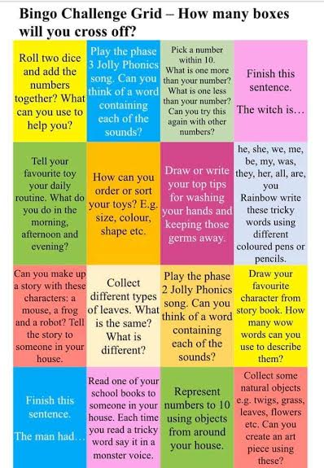
Share a book and say which character is your favourite.
Find something beginning with M, A, S
Roll a dice. Can you read the number?
Think of a sound. Can you find 3 things that start with the sound?
Practice writing any sounds you can remember
Additional learning resources parents may wish to engage with
You can use 2simple to try some new online control activities – more info coming soon!
If you haven’t already please ‘like’ our Facebook page St Peters’ Little Learners. We will be posting things on here for you to use at home.
#learningtogetherisfun

