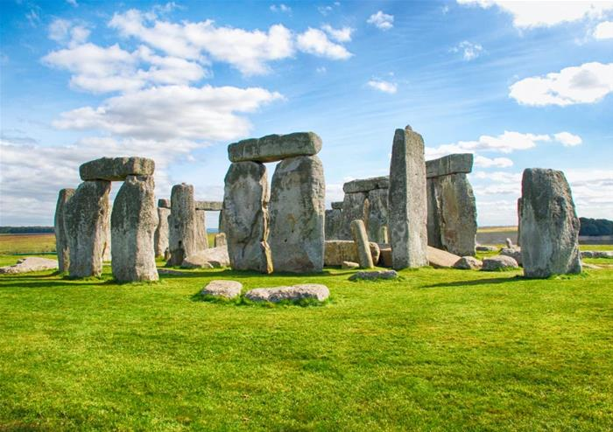

Years 3 and 4

Autumn term 2019

SCAVENGERS AND SETTLERS

**What was life like between the Stone Age and the Iron Age?**

**Year 3 Autumn Term Overview**

**Reading**

Class Novel – Stuck in the Stone Age by Geoff Rodkey

Other texts: Stone Age Boy, How to Wash a Woolly Mammoth.

**Key skills** – Inference and prediction based on evidence given, exploring vocabulary to help gain an understanding of the text and retrieve and record information.

**Writing**

Using a variety of texts, we will be exploring the different purposes of writing for audiences and how this affects the vocabulary and grammatical structures that we use. We will be writing instructions, recounts and stories all about our topic.

**Grammar**

We will be focusing on basic sentence structure, including how we use capital letters and full stops, conjunctions, fronted adverbials of time, a and an, the present perfect tense and how we apply informal language and technical vocabulary.

**Maths**

Power Maths Textbook A

* Place Value
* Addition and subtraction
* Multiplication and division

**Year 4 Autumn Term Overview**

**Reading**

Class Novel-Stig of the Dump by Clive King

Key skills-Inference and prediction based on evidence given, exploring vocabulary to help gain an understanding of the text and retrieve and record information. We will also be looking at characterisation.

**Writing**

Using a variety of texts, we will be exploring the different purposes of texts and audiences and how this affects the vocabulary and grammatical structures that we use. We will be creating explanatory texts, non-fiction pieces and writing stories about our topic.

**Grammar**

We will be revising over basic sentence structure, including how to use capital letters and full stops. We will also be looking at conjunctions, fronted adverbials, punctuating speech correctly, determiners, formal and informal language and technical vocabulary.

**Maths**

Power Maths Textbook A

* Place value
* Addition and subtraction
* Measure and perimeter
* Multiplication and division